JSail Tips’n’Tricks (v. 3.0) by Eduard Rodes
JSail is a fantastic tool that allows sailing higher than the other Optimist sails in the upwind and offers an unbelievable power in the downwind. It is really fast… 7 wins in the last 10 World Championships are the best evidence
This is obviously very good, but it also means that the JSail is not like all the others and needs to be trimmed and tuned in its particular way. Let me give you some ideas that will help you to find the way to get the best performances from your JSail in all conditions.
Tips…
First of all it is to know that JSail is designed with a straight luff and a quite flat zone after it. If we compare a Jsail with other brands we will easily see that JSail is flatter than the rest of Optimist sails in the front first third of its surface. This gives a very good angle and speed, but it is really important that it remains always like that.
The mast, except in very light winds, will bend in a curve which is different in each particular case. I have measured a lot of masts, in many different classes, and I have never seen two of them bending the same… Each mast has its own personality, but they all bend and produce a curve.
If we rigged the sail not compensating the mast bending with the ties length (making them be long enough to keep the luff straight), we would force the luff to follow the mast curve, which would flatten too much the zone behind the luff, with the subsequent loss of power and capacity to pass the waves. So, what we want is that the luff always works as designed, absolutely straight. How to get it?
RIGGING THE SAIL, step by step
1. Put all the intermediate ties and corner ropes on the boom. Two laps at the corners and only one at the intermediate ties. The distance between sail and boom must be not more than 10 mm (Class Rules), but try to have it at not much less than those 10 mm.
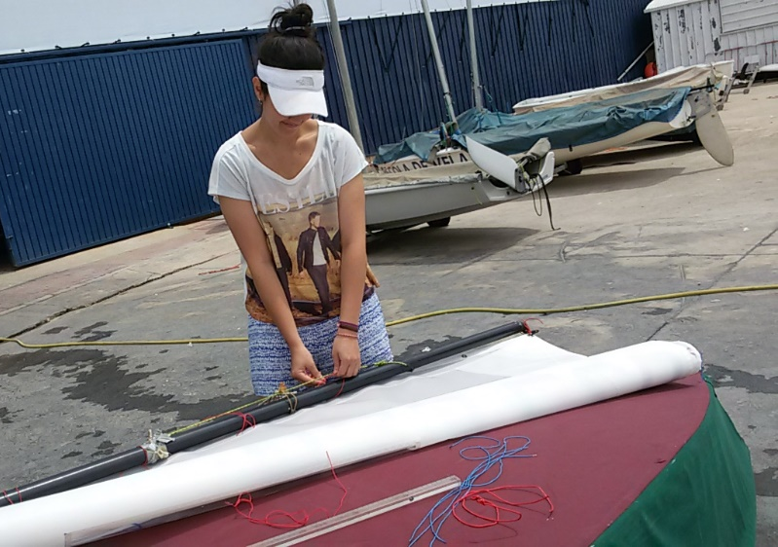
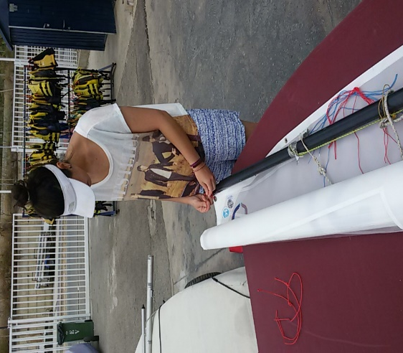

2. At the moment, just put the top and the bottom ties on the mast. Adjust both, the upper and the lower, to 1mm away from the mast. Two laps out and a very strong knot.

NOTE: The important ropes are those for the sail corners. The intermediate ones are just to obey the class rules; never use them for trimming purposes. They must be there to avoid big distances between the sail and the mast/boom that could be a danger for the sailor in case of capsize. If the work, if they tighten the sail, they will be taking power from it.
3. Adjust the height of the sail so that the mark is between the mast measure lines, a bit closer to the top than the bottom.
4. Put the sprit, step the mast on the boat and connect the main sheet to the boom ring.
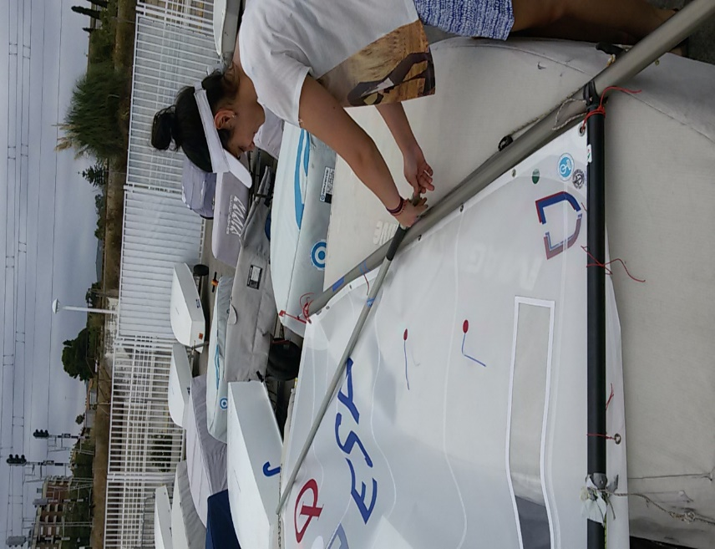
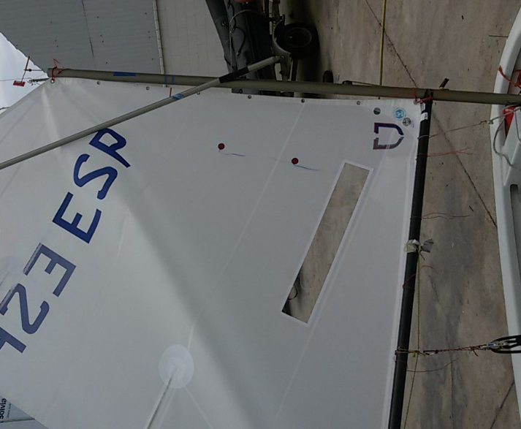

5. Tighten the outhaul to the max and tighten very strong the sprit, so a deep wrinkle will appear on the sail.

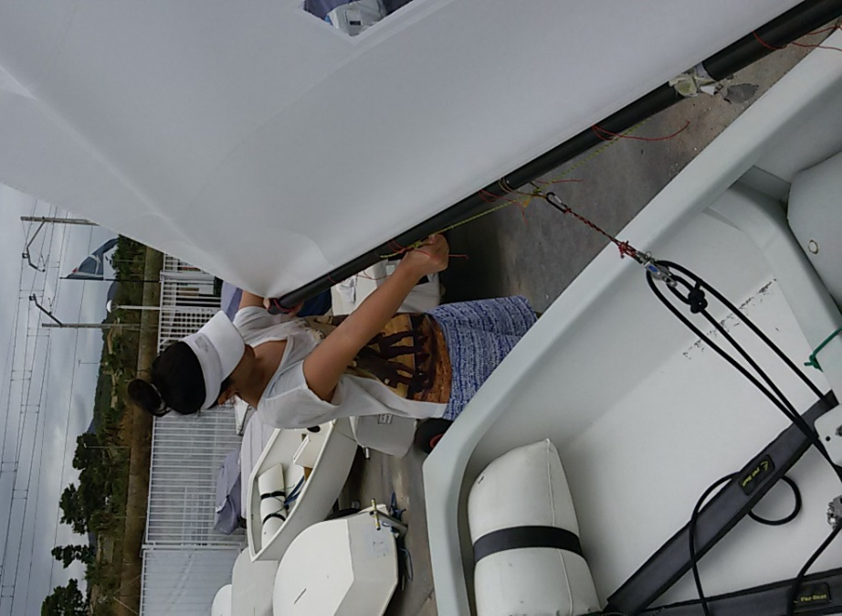
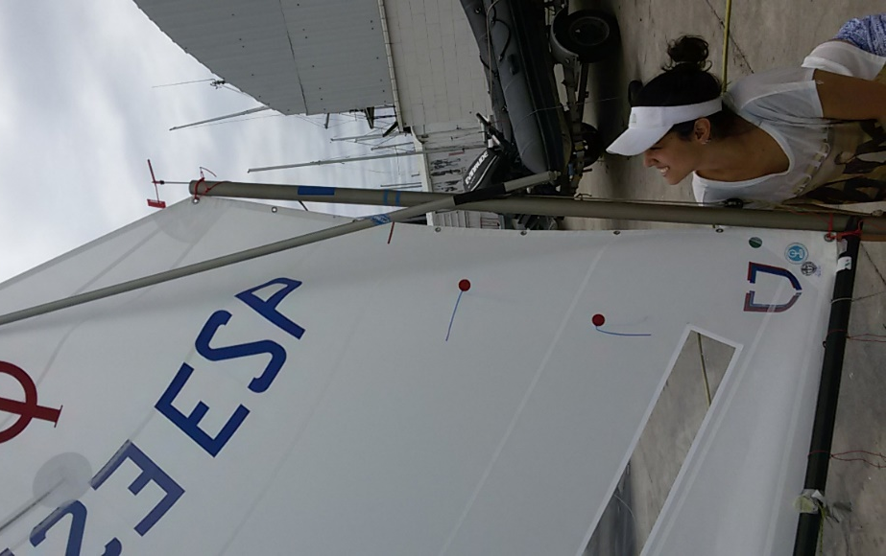

6. Tighten the sheet until the wrinkles disappear and fix it. The mast will bend creating a distance to the sail in the centre, but the luff will still be in its natural shape.
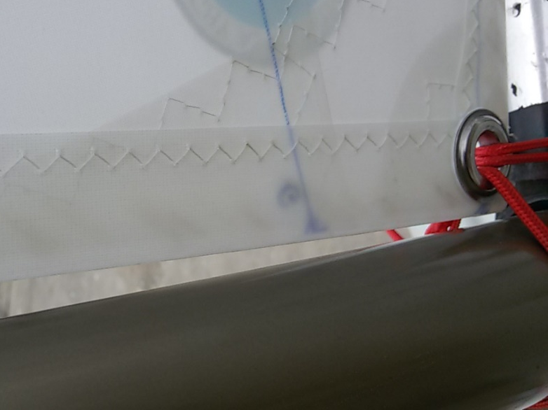
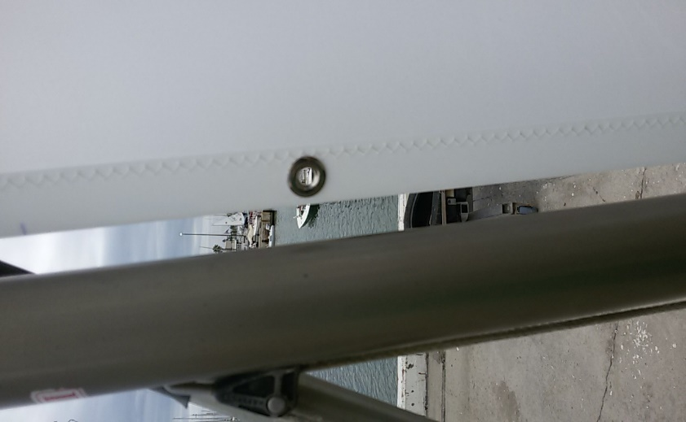
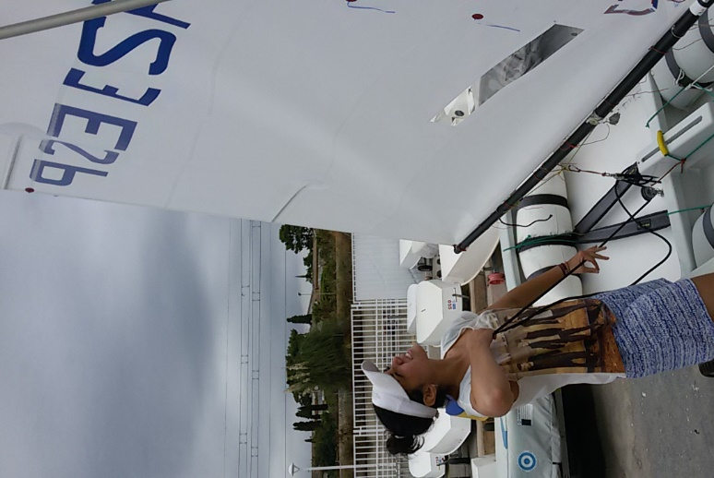
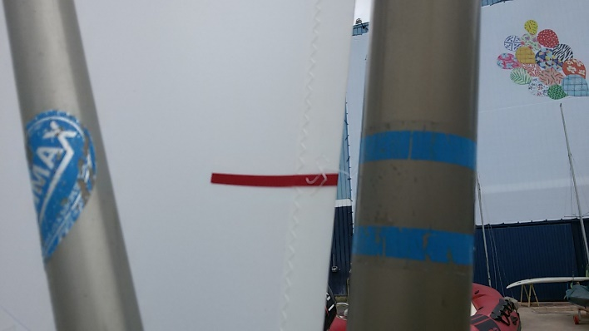
Important: Make sure that the maximum distance between the sail and mast reaches (but does not exceed) the 10 mm allowed by the rules. If there are less than 10 mm may be that we have not tightened the sheet enough or the mast has a curve that does not reach that distance. If so, it is necessary to increase the distance between the corners and mast. If the opposite happens then just make the distance between corners and mast shorter. Repeat the operation to make sure that you get those 10 mm. In the photo you’ll see that we increased a little the distance at the bottom corner to reach the 10 mm at the luff centre.

7. Make sure that the measurement line in the sail is between the two mast bands (just below the top one). Readjust the height adjuster in the sail top corner if necessary.

8. Adjust the luff tension by lifting/dropping the boom at the gooseneck. The sail must present a very slight vertical ripple just behind the luff. Then, with the correct luff tension, adjust the cunningham rope (see the tricks bellow). It has to be in 0 turns and very tight.

9. Put the intermediate ties. Simply respect the distances that appear at each point. The ties should be snug but not tight; they must not make any tension on the sail or they will depower it.

And that's all! We have rigged the sail for extreme conditions, but if you ease the kicker, the outhaul (wrinkles should never appear on the straight seam between the corners ... tie a knot at the end of the rope to avoid easing it too much), you give a complete turn at cunningham and adjust the sprit tension to the new necessities... you'll see how nice your sail looks for light winds!
With this procedure we have adapted the sail to your mast and, if you don’t undo the ties (if you have to do it repeat all the procedure from the beginning because next time you do them will be a bit shorter or longer, which changes all tensions), it will always work well, whatever the wind is. It will only be necessary to adjust the sprit, the kicker, etc., but never the ties. But… how to adjust the sail?
SAIL TUNING
Light winds (0-8 knots) flat waters:
Luff: 1 turn at the cunningham.
Sprit: We will establish the sprit to the prevailing wind, it must look a little loose in the gusts.
Outhaul: Some tension. Flatten slightly the sail in these conditions reduces the drag and improves the speed and allows you to sail a bit higher in the upwind course.
Kicker: Just tight enough to keep the cunningham tight.
Light winds (0-8 knots) with waves:
Luff: Half turn at the cunningham.
Sprit: As in the previous case.
Outhaul: Ease it to the maximum sail depth, but avoid producing wrinkles.
Kicker: As in the previous case
Medium winds (9-14 knots):
Luff: Half turn at the cunningham
Sprit: As mentioned, the tension has to be enough to avoid folds, but some wrinkles must appear in the gusts.
Outhaul: The outhaul should be set according to the wave conditions. If flat waters, a bit tight. The bigger waves we have to face, the looser the outhaul has to be, but never producing wrinkles.
Kicker: Tight enough to keep the sheet tell tale flying most of the time during the upwind course.
Strong winds (15 knots and more ) :
Luff: O turns (never remove)
Sprit: If you are very overpowered, ease the sprit enough to produce a deep diagonal fold on the sail. It divides the sail in two parts… ugly, but very effective.
Outhaul: The more you need to reduce the sail power, the more you will tighten the outhaul, but never to the limit.
Kicker: Very tight, forcing the mast to bend.
And now, an extremely important point:
MAST RAKE
It will give us the necessary balance to use the rudder just for driving the boat (the rudder should never be used to keep the boat straight, only to drive it).
1. Keep starboard tack, upwind, with absolutely flat boat. Sit exactly where you'll be during the race. When you have the sail tale ties working properly release the rudder. If the boat goes too quickly to upwind, give the mast base some turns clockwise direction. If it goes to downwind, do the opposite.
2. Repeat the operation as many times as you need to get the correct result: the boat must go very gently to windward, whatever the wind force is. If it is very windy you will have to increase the rake a lot. Don’t count the turns you give to the mast base… Don’t stop doing it until the boat is balanced. Only when the boat behaves as it should ... the rake is the correct one.
3. Repeat this process before each race... if one day you have 5 races, don’t hesitate, do it 5 times and readjust the rake to the new necessities. The correct rake is a key point for speed and upwind angle.
4. ... and simply forget the measurement tape! Do not use it anymore. The rakes are correct only one time… you can have one that works very well today and be absolutely wrong tomorrow, even in very similar wind force.

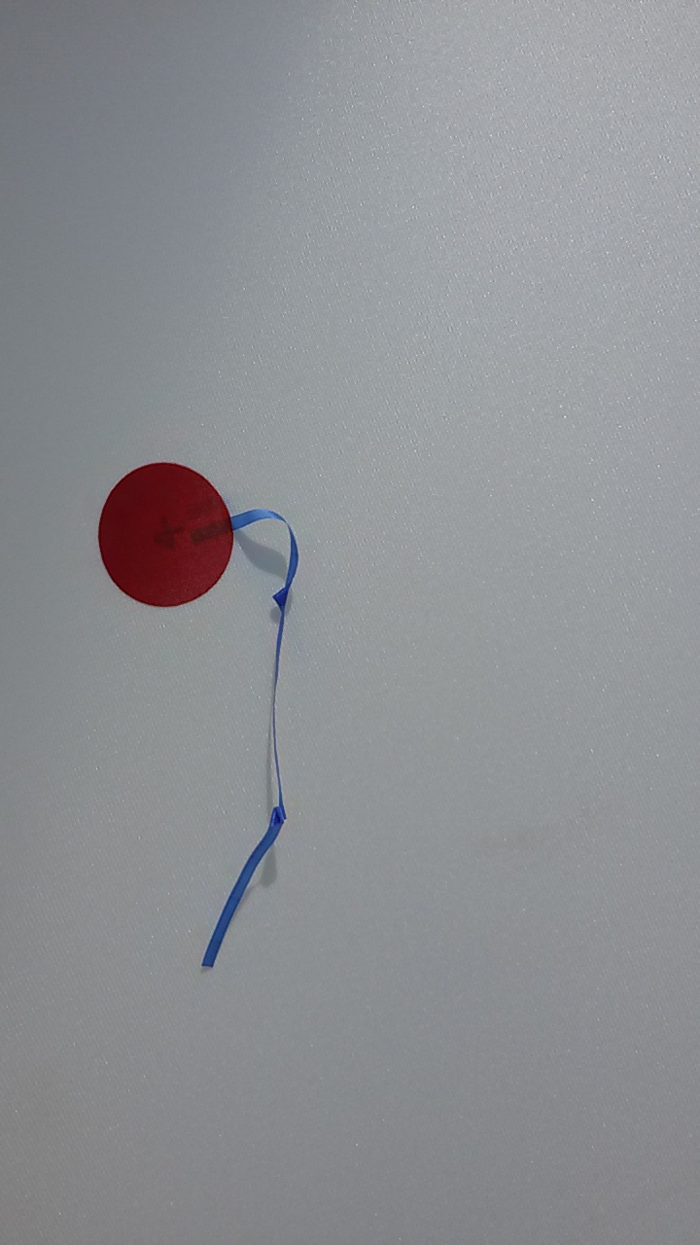
…and tricks
Tell tales
JSail includes a double set of tell tales made in a very light spinnaker cloth, which fly very easy and help very much the sailor to find the best angle with the wind, especially in the upwind course. But sometimes we can capsize, it can rain or simply the tell tales get wet… they get attached to the sail and it can take a very long time to fly again. What I propose is to divide the tail-tales in three parts by doing a couple of quite loose knots in each of them. They give the tail-tales a certain distance from the sail and help the wind to make them fly much earlier.

Sail corners ropes and knots
Always use very good stuff in these points. In my opinion the best, for the lack of elasticity and the thickness, can be found in Optiparts, the 2.2 mm vectran core rope (EX13672). Polyester ropes under tension can be amazingly elastic, and the best is to have always the same distances at the corners. Only the very good ropes can assure it.
Remember that the first time you use a rope it will be a bit longer at the end of the day… in the case of the vectran core it will be because the knots will get tighter which gives the rest of the rope a longer distance.
Remember that we should only trim the sail acting on it from the corners. That’s why those ropes are so important and also that’s why the rest of the ropes should never work. So, if the corners are so important, not only the ropes have to be good and trustable, the knots have a very relevant roll too. When we set the sail we want it to be always the same, not changing depending on the gusts or the wind conditions. And very often the knots we make are not good enough… the distances change and the sail performance may drop substantially.
I propose a system that not only helps the sailor to find easily the correct distances between the sail and the spars at the corners, but assures that they will be permanent as well. Most of the sailors use the square knot there… and it is a very bad knot for it. When you have to adjust it you must act on both terminals, which makes it very difficult to know if you are tightening it too much of not enough. And the square knot is famous for how slippery it can be under tension.
Do it as follows.
1. Do a very small, the smallest you can do, bowline on one of the terminals and give two laps around the eyelet and the spar.
2. Pass the terminal through the bowline and adjust the distance between the sail and the spar.
3. Do a simple knot around the bowline and tight it as much as you can

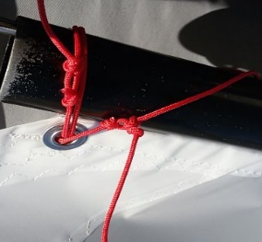
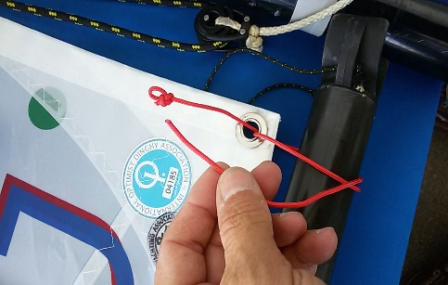
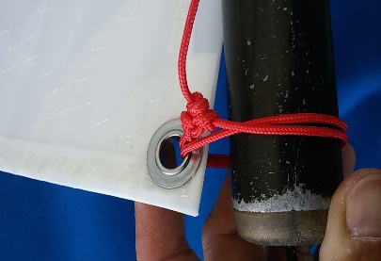
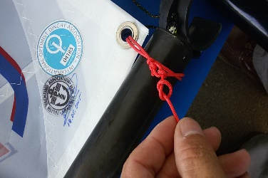

4. Do one more knot over the terminal to stop the rope sliding inside the first knot.
5. Check the distance… if any adjustment is necessary it will be very easy to adjust only one terminal.

Do this in all the corners and also (but with only one lap) on the high adjuster, at the top of the mast.
In all cases, remember that after some use the distances may have changed… the sun, the tensions, etc. will always produce some changes in the ropes and knots length. It is always convenient, specially before the regattas, to check the ropes. And remember, unless it can be avoided, never use a rope for first time in a regatta.

Rope between corner and kicker.
When we adjust the luff tension we want to have the distance between the sail and the boom always the same. But especially in light winds, the rope can slide forward and get close to the gooseneck, which is thinner than the boom, and the corner raises. It seems to be not much, but the effects on the luff tension can be dramatic. To avoid it simply install a thin rope between the corner rope and the kicker. Do a bowline around the corner rope and a normal knot at the kicker. It must not be tight… it should only work to avoid the corner rope slide forward.

Sail foot and luff ropes
Again, the intermediate ropes have to be there because of the Optimist Rules, nothing else. Their only purpose is to avoid distances between the sail and the spars that could create a dangerous problem to the sailor in case of capsize absolutely nothing to be with trimming. The rules allow up to 10 mm… and the best we can do, at least in the case of the boom (for the mast please see the tuning guide), is to have always those 10 mm there. Never, let me insist and emphasize in this point, never give two laps to them (but remember to do them in the corners). It is an extremely common mistake. As I said before, the ropes are not there to help you with the trimming, it simply is a rule requirement due to safety reasons. So, if they are not there to help, the best they can do is not to disturb, and two laps doubles the resistance the sail finds when changing from one side to the other during the maneuvers. And there, the square knots, with an extra knot on it if you want, are good enough.
In most cases, the sails will arrive to you with ropes long enough for two laps… just ignore it. Simply cut the excess and you’ll even make your boat lighter
Cunningham rope and knots
Most sailors, even in quite high level don’t realize how important this elements are. The cunnigham is a relevant control which good use gives us not only the correct power in each case but a better angle as well.
In the majority of the cases, the boats have a simple rope, whatever the size is, with a fix knot at each end under the boom holes. No way to change the length or to adjust correctly the tension in case of necessity.
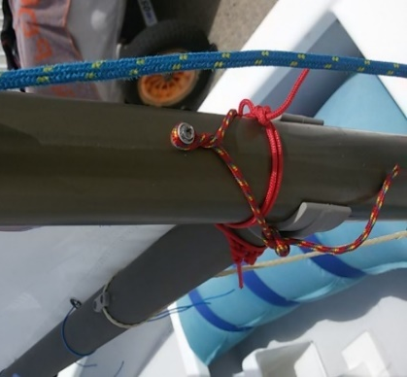
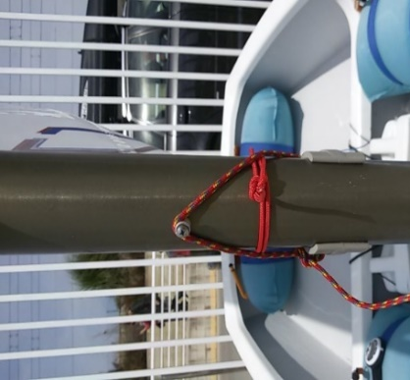
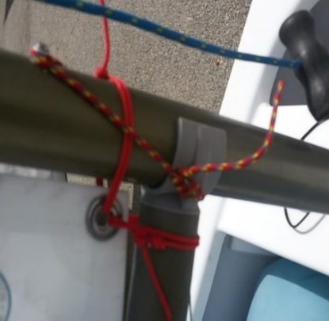

What I propose is a system which can be very easily adjusted and which gives the sailor the references to have always the best luff tension. Simply pass the rope through on of the boom holes and do a knot on the terminal. Then pass the rope over the mast screw and then through the second hole and do several knots around it giving the rope a long enough distance after them. When well adjusted, with zero turns it will be perfect for strong winds, with half turn for medium winds and with one turn for light winds. But it has to be perfectly adjusted (see the tuning guide) and that’s why we do those knots; in case of necessity, they are easy to undo and readjust the length (for instance, when we have to change, even a very little, the height of the sail on the mast)
Again, the best rope, and the size that assures that the explained number of turns is correct, is the one recommended for the sail corners (reference EX13672 of Optiparts)
Electric tape on the ties
When we adjust the ties we put them horizontal, but when there’s no tension they drop. When sailing, when the mast bends, the distance between the sail and the mast has to be the same than the one we had ashore, but the new position of the ties makes it shorter… to avoid it simply put a little of electric tape on the ties to assure that they will always be in the correct position and will never work.

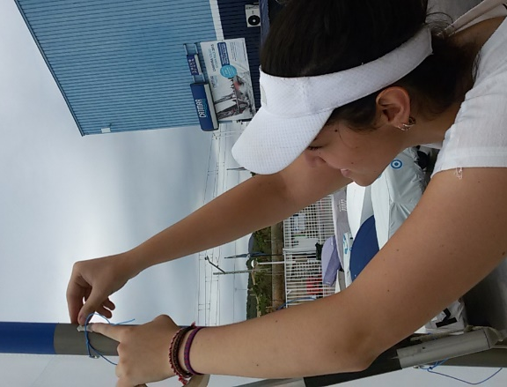
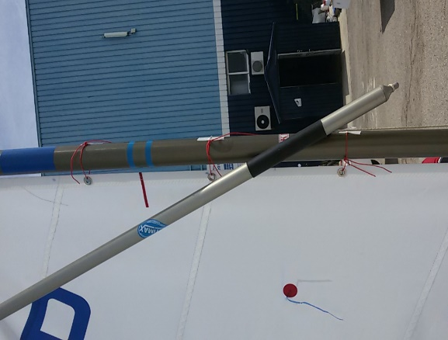

I really hope that all this helps you to sail faster and enjoy your fantastic JSail!!

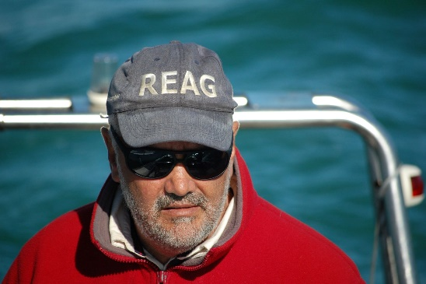
Eduard Rodes
International Coach
Regatta Judge
JSail dealer for Spain
www.eduardrodes.eu

My daughter Cristina, who appears on the photos, was the main sailor who helped me to develop this tuning guide. Some of the best ideas are hers. She currently is a coach too.

